**Random variable:** variable whose value is assigned by the outcome of a random circumstance,

Or each unit of population

Two classes:

1 – Discrete random variables

Values can be one of countable list. Eg. Natural numbers:1,2,3,4…. / Whole numbers: 0,1,2,3….

2 – Continuous random variables

Values can be anything in an interval or multiple intervals.

***Ex1:***

Discrete: number of courses, number of siblings, shoe size, (student number) (things you can count)

Continuous: height, weight, length of foot, age (things you can measure)

***Finding Probabilities:***

Discrete: -we can find probabilities for exact values

P(one sibiling)=12/33 random variable=1 P(X=1)=12/33

Continuous: -we only find probabilities for **intervals** of values.

P(height between 173 and 175cm)=

*Discrete-separate*

*Discreet-keep quiet*

Notation:

X 🡪 the random variable

K, Xi, 🡪 any particular value X could take

P(X=K) 🡪 probability x takes value K

Table of formula that list all probabilities:

Probability distribution function (pdf)

Rule: 🡨 sum of all probabilities is 1 0≤P(X=K)≤1 🡨 probabilities are between 0 and 1

***Ex2***

Flip 2 coins, X is the number of heads

Simple event: HH HT TH TT

Valve of X 2 1 1 0

Probability ¼ ¼ ¼ ¼

P(X=2)1/4 P(X=1)=1/2 P(X=0)=1/4

|  |  |
| --- | --- |
| K | P(X=k) |
| 0 | ¼ |
| 1 | ½ |
| 2 | ¼ |

Graph eg

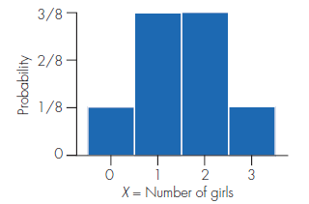 area of each bar=the probability area=1x1/8=1/8

Cumulative distribution function (cdf)

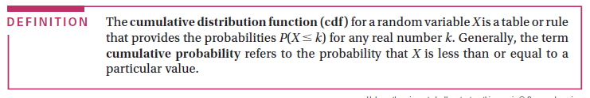

**Expected value:**

~mean value(weighted) of the RV in the sample space

~long run average

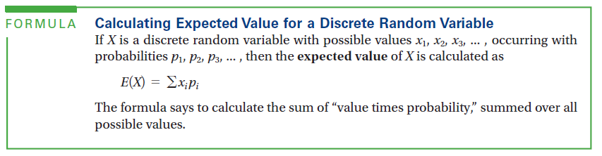

Always use PDF values for this formula

Ex4 X=number of heads in 2 coins

$µ=E\left(x\right)=\sum{\left(Xi*Pi\right)}$ =(0)(1/4)+(1)(1/2)+(2)(1/4)=1/2+1/2=1 heads

$V=E\left(x\right)=\sum{{\left(Xi-µ\right)}^{2}*Pi}$ =(0-1)^2(1/4)+(1-1)^2(1/2)+(2-1)^2(1/4)=1/4+1/4=1/2=0.5 heads^2

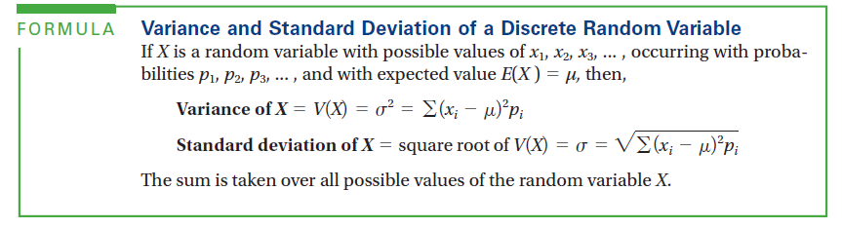

***For populations***:

